Task 2:
Learn how Python communicates with external APIs and handles JSON data.
Code :
import requests
city = input("Enter city name: ")
API_KEY = "f6e581aae06c444782b45fce79b6a180"
url = f"https://api.openweathermap.org/data/2.5/weather?q={city}&appid={API_KEY}&units=metric"
try:
response = requests.get(url)

if response.status_code == 200:

data = response.json()
temperature = data["main"]["temp"]
humidity = data["main"]["humidity"]
description = data["weather"][0]["description"]

print("\nWeather Details")
print("----------------")
print("City:", city)
print("Temperature:", temperature, "°C")
print("Humidity:", humidity, "%")
print("Condition:", description)
if temperature > 30:
print("Hot Weather")
else:
print("Cool Weather")
else:
print("Error:", response.status_code)
except requests.exceptions.RequestException:
print("Network Error")

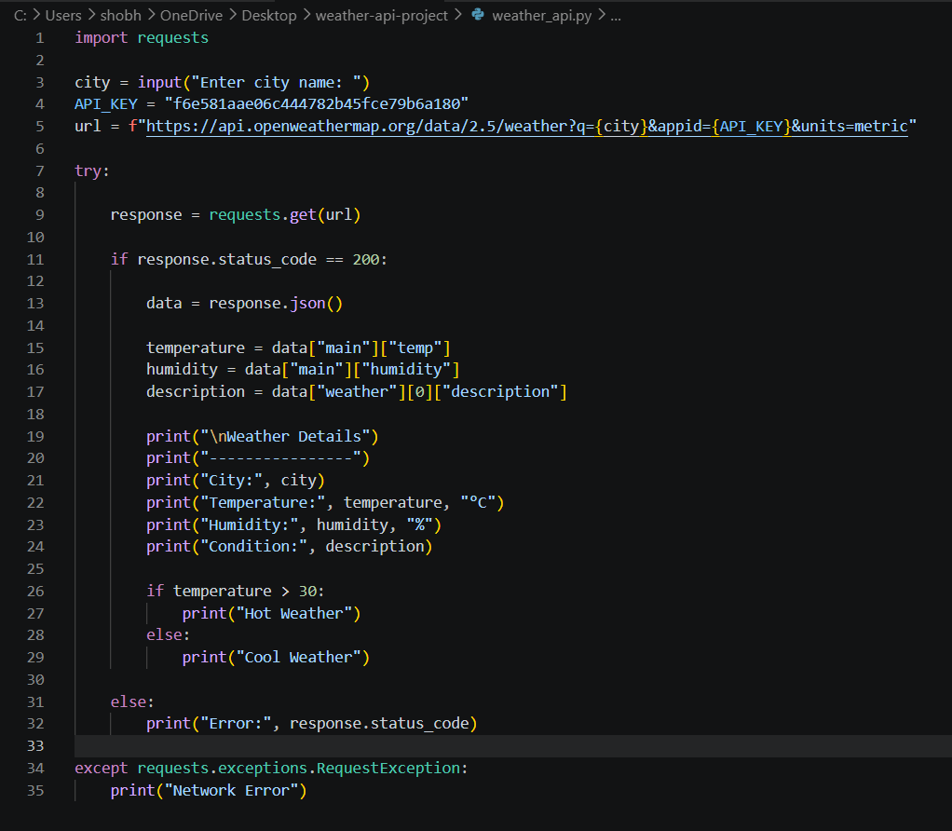
code:
output :
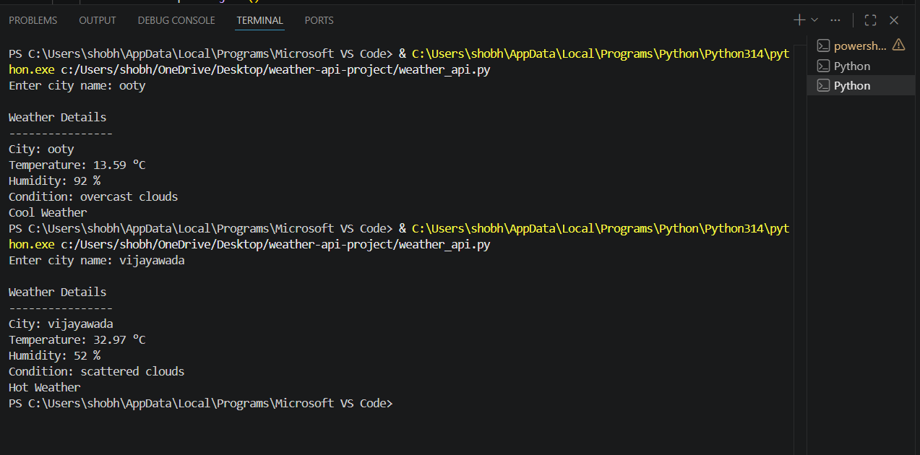

Code snippets:
- Import Requests
import requests
- User Input
city = input("Enter city name: ")
- API Key
API_KEY = " f6e581aae06c444782b45fce79b6a180"
- API URL
url = f"https://api.openweathermap.org/data/2.5/weather?q={city}&appid={API_KEY}&units=metric"
- Send API Request
response = requests.get(url)
- Parse JSON Response
data = response.json()
- Extract Temperature
temperature = data["main"]["temp"]
- Extract Weather Description
description = data["weather"][0]["description"]
- Handle API Errors
if response.status_code == 200:
print("Success")
else:
print("API Error")
- Filtering Logic
if temperature > 30:
print("Hot Weather")
else:
print("Cool Weather")
- Network Error Handling
except requests.exceptions.RequestException:
print("Network Error")

hosted link: https://gist.github.com/SRUJANA1525/27ec610b9bbcab5e25e2e701f25c987f

github repo link: https://github.com/SRUJANA1525/alfido_tech_Task2.git

